Dear Editor (Prof Kedling Lu),
Re: TS1 Amendment of Figure 3.
While reading the proof typeset manuscript, the authors realised that Panel (d) within Figure 3 was incorrect. Please see Figure 3 (Original).
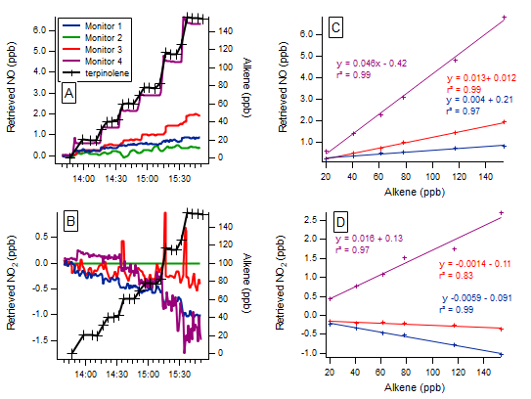
Figure 3 (Original). Time series of the terpinolene mixing ratio and measured NO and NO2 mixing ratios, as retrieved by each monitor (a, b), with 1 min time resolution, and the regression calculations for the monitors that demonstrated significant interference with the addition of terpinolene (c, d). Note the different y axis scales.

Panel (c) and (d) are both interferences determined by means of linear regression (least squares fit), with the slopes and their uncertainty and Pearson’s correlation coefficients calculated in IGOR (as outlined in Section 3.2 of the manuscript). In Panel (d) it should be noted that the correlation of Monitor 4 (purple line) is incorrect. This should be a negative correlation as can be determined by visualising the NO2 signal from Monitor 4 in panel (b).
This is therefore incorrect and was not identified in the review process or by the authors prior to proof reading. This Figure should therefore be corrected to Figure 3 (New), which shows the correct negative correlation for Monitor 4, in panel (d).
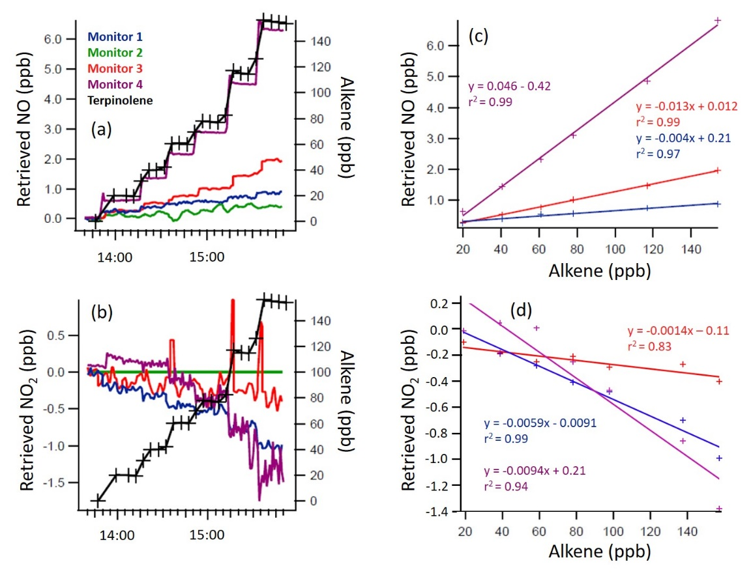
Figure 3 (New). Time series of the terpinolene mixing ratio and measured NO and NO2 mixing ratios, as retrieved by each monitor (a, b), with 1 min time resolution, and the regression calculations for the monitors that demonstrated significant interference with the addition of terpinolene (c, d). Note the different y axis scales.

This Figure is also attached as a JPEG for your information.

We have also noted that this will need to be corrected in Table 3 also:
Table 3, for Terpinolene: 4th line, 5th column – Air Quality Design, Inc: The NO2 interference should be amended from “1.60 ± 0.10*” to “-0.94 ± 0.21*” Everything else in the manuscript should remain the same. This change in result (from the correlation amendments in Figure 3(d)) does not affect the discussions or conclusions of this study.

We would like to thank you for your cooperation and look forward to hearing your positive response.

