The requested changes are as follows:

Page 8, Figure 4:

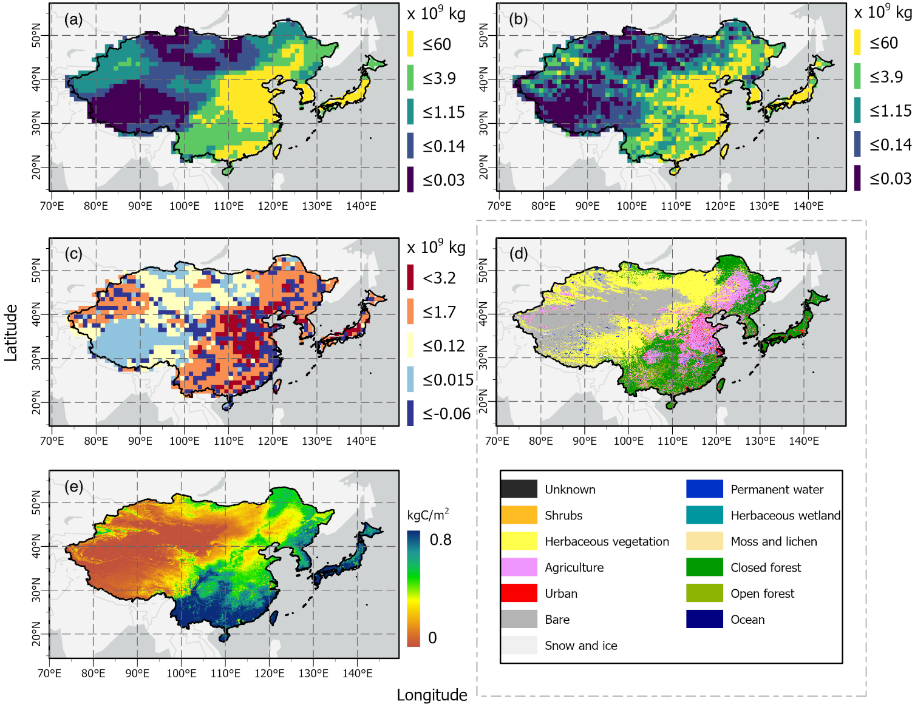
Please exchange the current figure with the following one:

Explanation: The color bar label of Fig. 4e is incorrect. The upper limit was 0.8000, but due to space issues, the "0." was omitted. The new upper limit should be 0.8.

P. 9, Fig. 5:

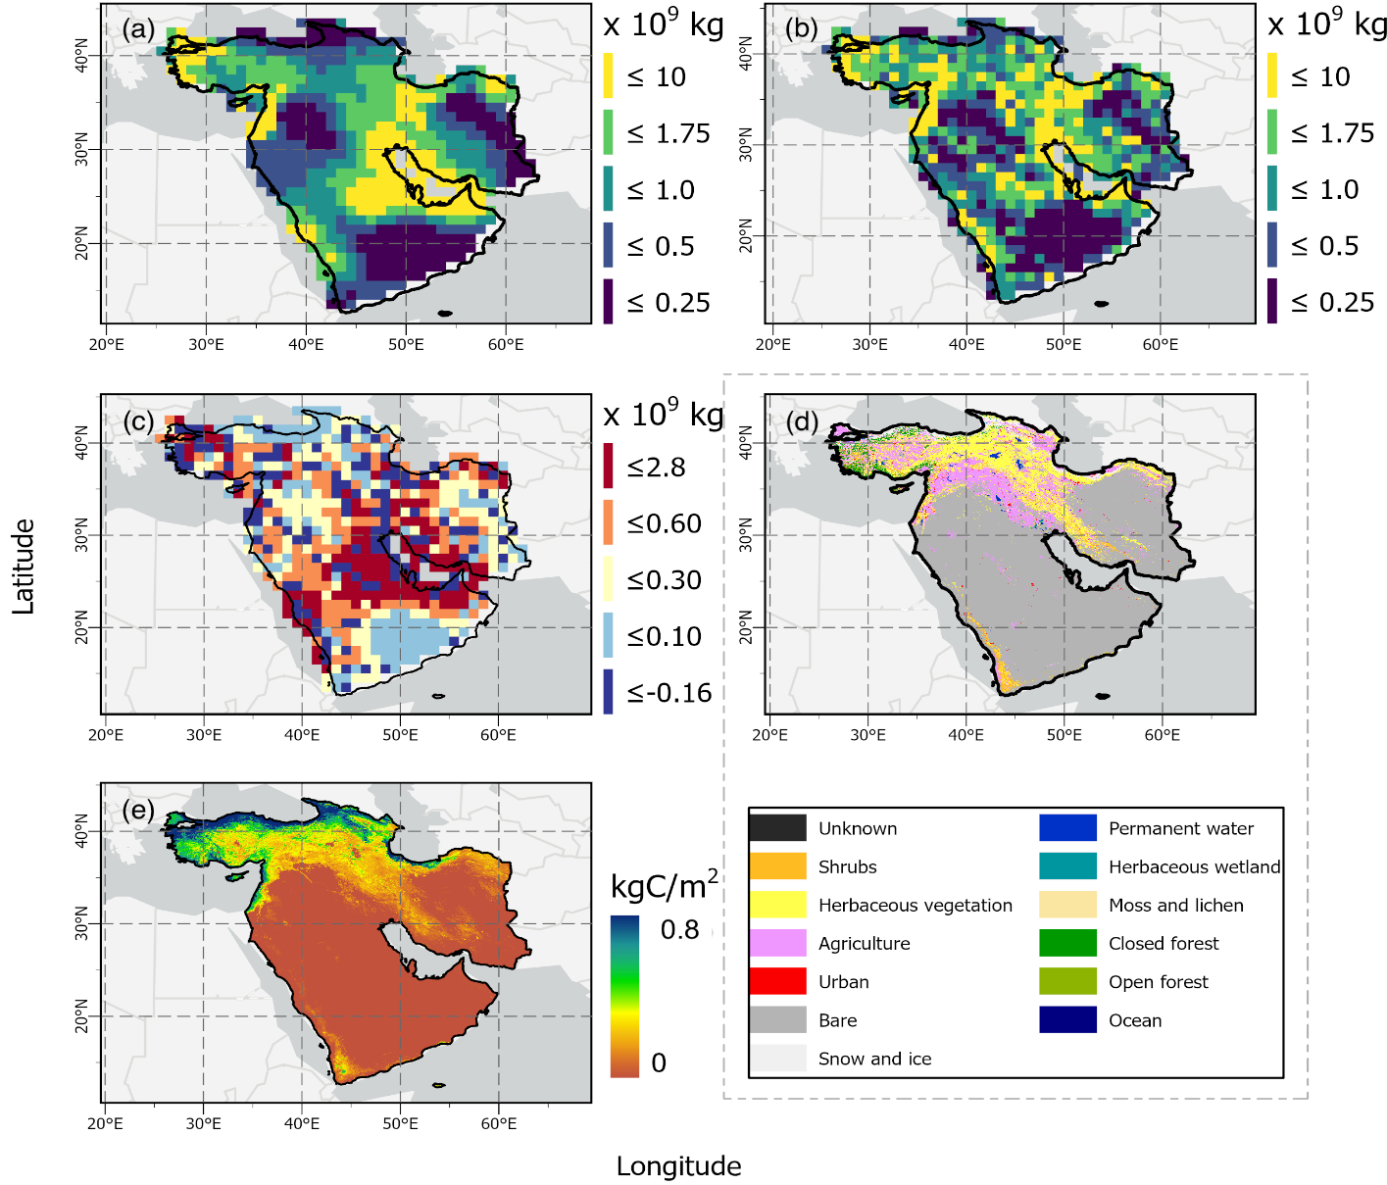
Please exchange the current figure with the following one:

Explanation: The color bar label of Fig. 5e is incorrect. The upper limit was 0.8000, but due to space issues, the "0." was omitted. The new upper limit should be 0.8.

