The requested changes are as follows:

Page 3, Eqs. (3) and (4) (TS1):

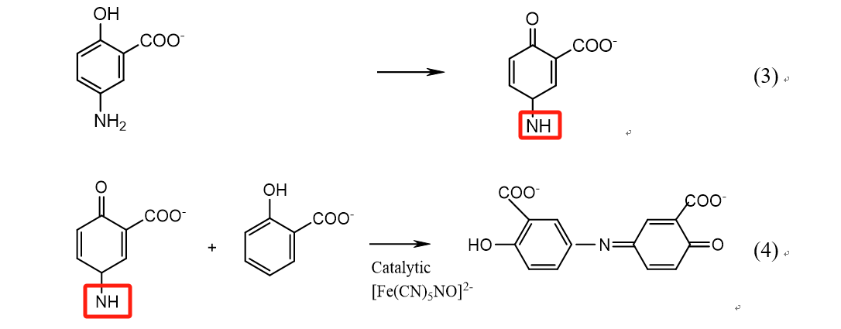

Explanation: There was a slight mistake in Eqs. (3) and (4) due to a handwriting error, which had no effect on the fundamentals of the study and the results of the data. For the sake of the accuracy of the article, we hope to make corrections. Thanks.

Page 3, right column, line 7 (TS2):

Please change “NH₃” to “NH₄⁺”.

Explanation: There was a slight mistake due to a handwriting error, which had no effect on the fundamentals of the study and the results of the data. For the sake of the accuracy of the article, we hope to make corrections. Thanks.

